Timmins CWL Executive attending the Fall Meeting, October 15, 2022
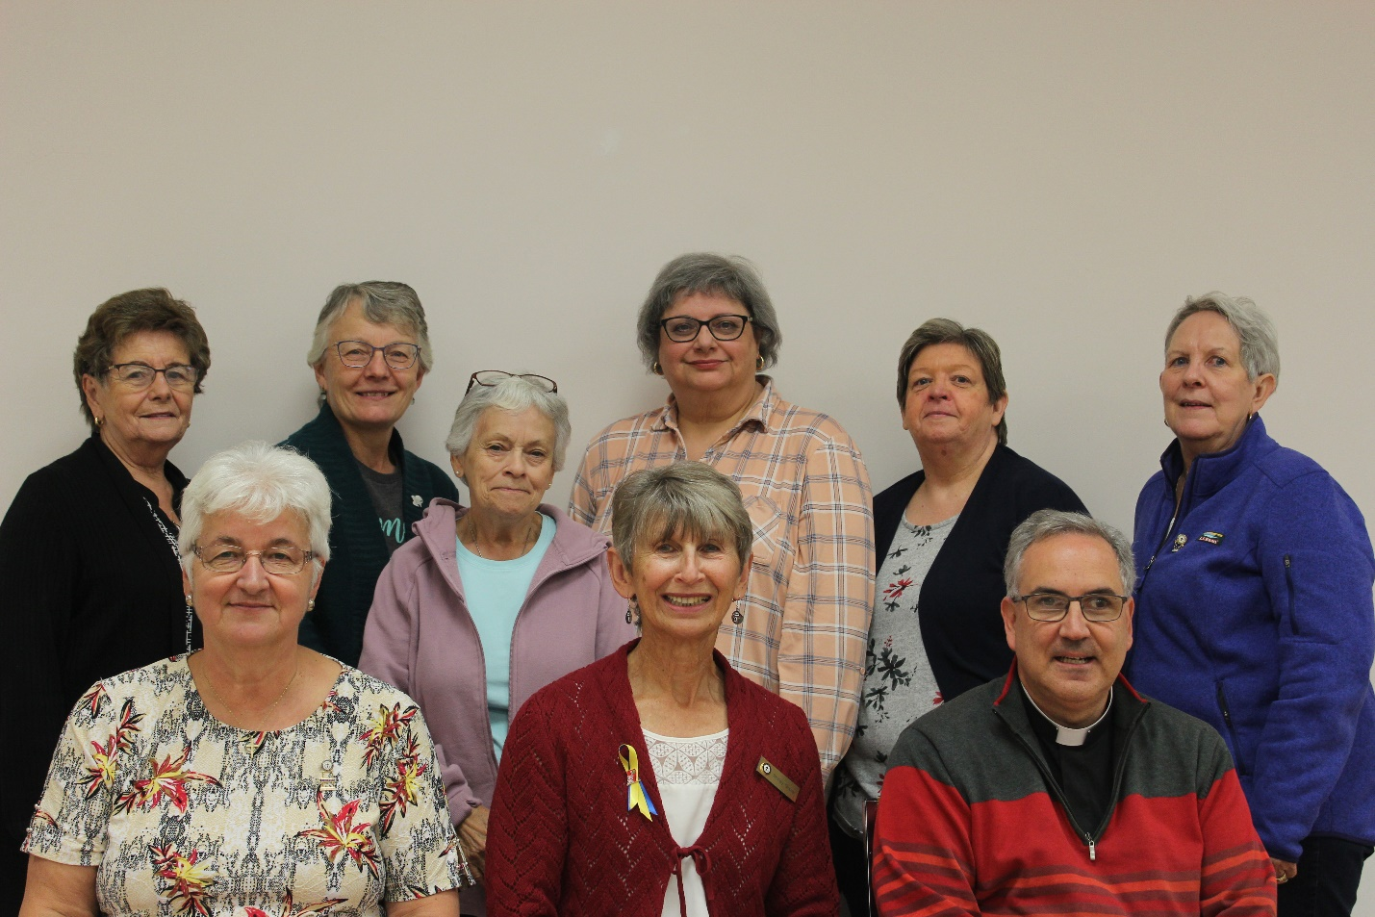

Back row left to right: Colleen Landers (St Anthony of Padua President & Diocesan Communications Chairperson), Audrey Shelton, OMPH President), Yvette VanLankveld (Spiritual Development Chairperson),Armida Millions (Recording Secretary), Peggy MacInnis (Treasurer), Lynne Rowlandson (Holy Trinity President & Diocesan Organization Chairperson).
Front row left to right: Annette Kelly (Past President/Historian), Shirley Gravel (Diocesan President), Fr. John Lemire (Diocesan Spiritual Advisor)

